Number of active duty servicemen as of August 2016
Army – 539,675 (37.8%)
Navy - 326,684 (22.9%)
Marine Corps – 198,415 (13.9%)
Air Force – 322,900 (22.6%)
Coast Guard – 41,362 (2.9 %)
Total – 1,429,036 (100%)

Age Distribution
Age Distribution of Active Duty Force
Service | 18-21 | 22-30 | 31-40 | 41-50 | 51-59 | Average Age
Army | 18.3 % | 48 % | 25.6 % | 7.9 % | 0.7 % | 29
Navy | 18.6 % | 46 % | 26.3 % | 8.3 % | 0.8 % | 29
Marine Corps | 36.9 % | 46 % | 14 % | 3.1 % | 0.2 % | 25
Air Force | 14.4 % | 46 % | 28.3 % | 10 % | 0.6 % | 30
Coast Guard | 12.2 % | 48 % | 27 % | 12 % | 1 % | 30

Race Distribution
Race Profile of Active Duty Force
Service | % White | % Minorities | % Black | % Other
Army | 73.9 % | 26.1 % | 21.5 % | 4.6 %
Navy | 66.2 % | 33.8 % | 19.3 % | 14.4 %
Marine Corps | 83.7 % | 16.3 % | 11.1 % | 5.2 %
Marine Corps | 83.7 % | 16.3 % | 11.1 % | 5.2 %
Coast Guard | 82 % | 18 % | 6.1 % | 11.9 %
Total | 74.6 % | 25.4 % | 17.8 % | 7.6 %

Gender Distribution
Active Duty Gender Distribution
Service | Enlisted Percent Female | Officer Percent Female
Army | 13.2 % | 15.5 %
Navy | 15 % | 15.1 %
Marine Corps | 6.2 % | 5.8 %
Air Force | 19.9 % | 18.3
Coast Guard | 11.6 % | 14.9 %
Total | 14 % | 15.3 %

Among Veterans who use VA health care:
Low statistics because hardly anyone reports abuse or weakness while in the military and by the time they get out they are trained to be ashamed or ignore abuse or weaknesses to save pride and honor.
Sexual assault / harassment
- 23% of women reported sexual assault in the military
- 55% of women experienced sexual harassment in the military
- 53% of men experienced sexual harassment in the military
Poverty rates by gender and age
- (age: 17-34) Men = 10.5 %; Women = 13.1 %
- (age: 35-54) men = 7.4 %; Women = 8.0%
- (age 55-64) men=9.5 % women =10.2%
- (age: 65+) men = 5% women = 8%
Source material: http://www.va.gov/vetdata/
http://sapr.mil/public/docs/reports/FY15_Annual/FY15_Annual_Report_Fac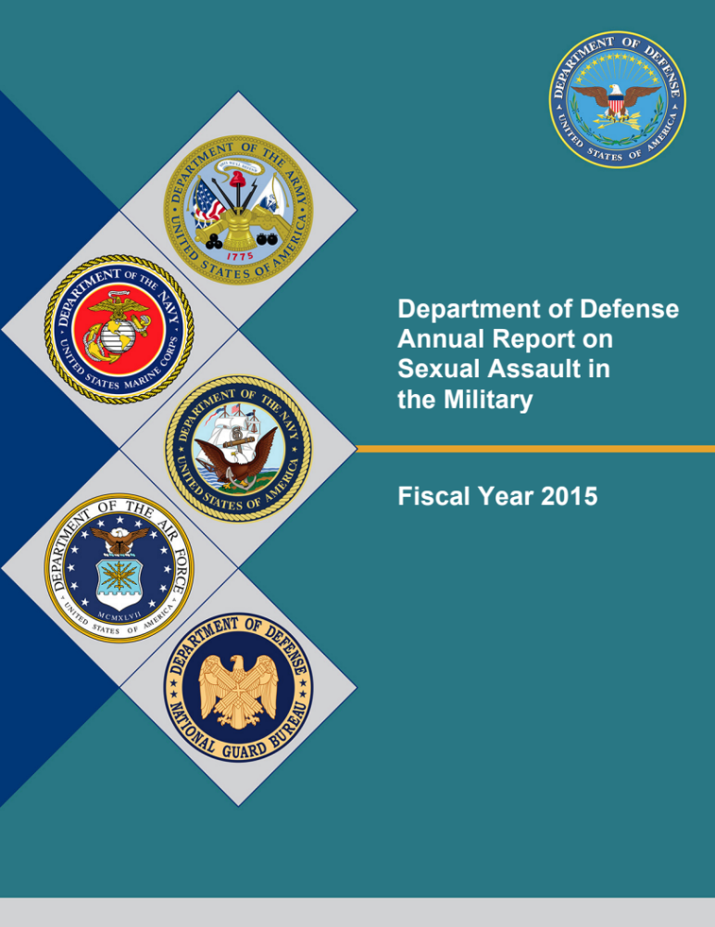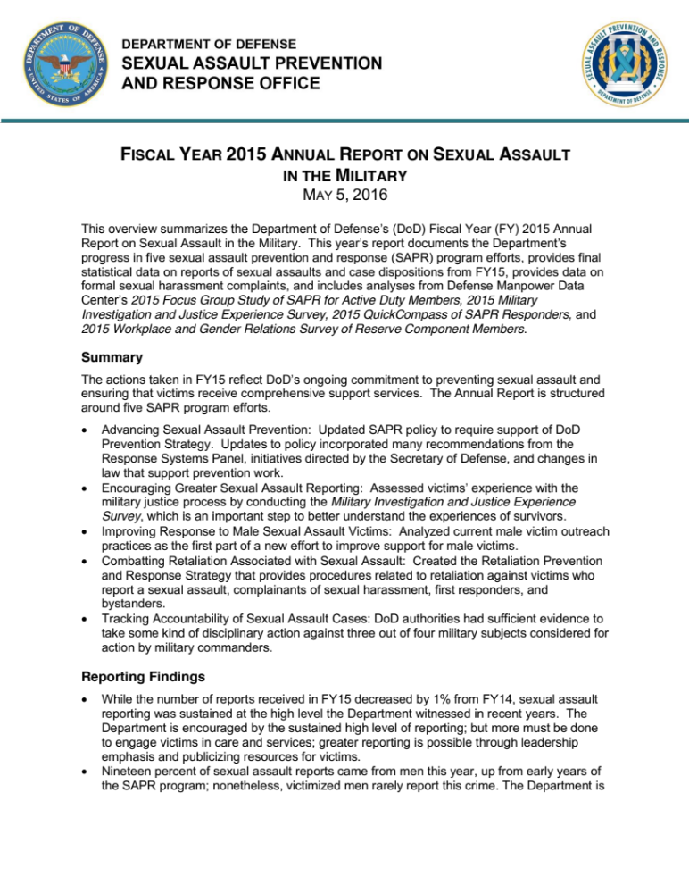t_Sheet.pdf

